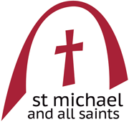**Sunday August 11th 2024**

**19th Sunday in Ordinary Time**

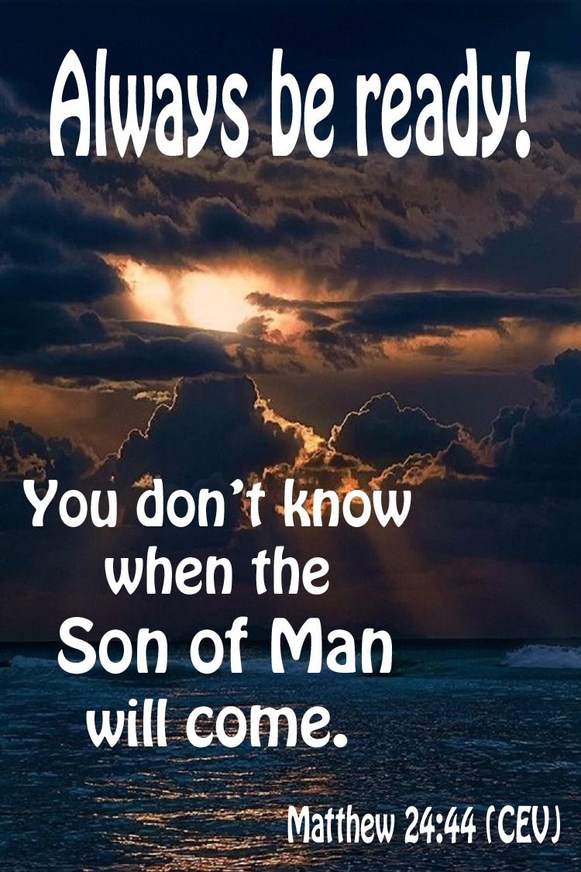

***Welcome to our church******and to this service***

The main part of the service is found in the green Mass in Ordinary Time booklet. This pew-sheet gives details of the parts of the service that change week by week.

***Everyone*** *is welcome to come forward at the giving of Communion, either to receive the Sacrament or a personal blessing.*

Gluten-free wafers and non-alcoholic wine are available on request. Please let the sidesperson know***.***

**Organ Music:** *Psalm Prelude,* Set 1, No. 2 (Op. 32) - Herbert Howells (1892-1983).

**Mass setting**: *Missa Brevis ‘Sancti Johannes de Deo’* – F. J. Haydn (1732 – 1809)

**Welcome and notices**

**Introit Hymn: 484 The Church’s one foundation**

**Introit** *(p.3*):Look, O Lord, graciously upon thy covenant, and

forsake not the congregation of the poor for ever: arise, O Lord, maintain thine own cause; and be not unmindful of the voices of them that seek thee. Ps. O God, wherefore art thou absent from us so long: why is thy wrath so hot against the sheep of thy pasture? Glory be.....

**Gloria***: (Haydn setting sung by the choir)*

**Collect** *(p.9)****:***Almighty God, thou hast sent thy Holy Spirit to be the life and light of your Church: open our hearts to the riches of thy grace, that we may bring forth the fruits of the Spirit in love, joy, and peace; through Jesus Christ our Lord, who livest and reignest with thee and the Holy Spirit, ever one God, world without end.

**Amen.**

**Old Testament Reading:**  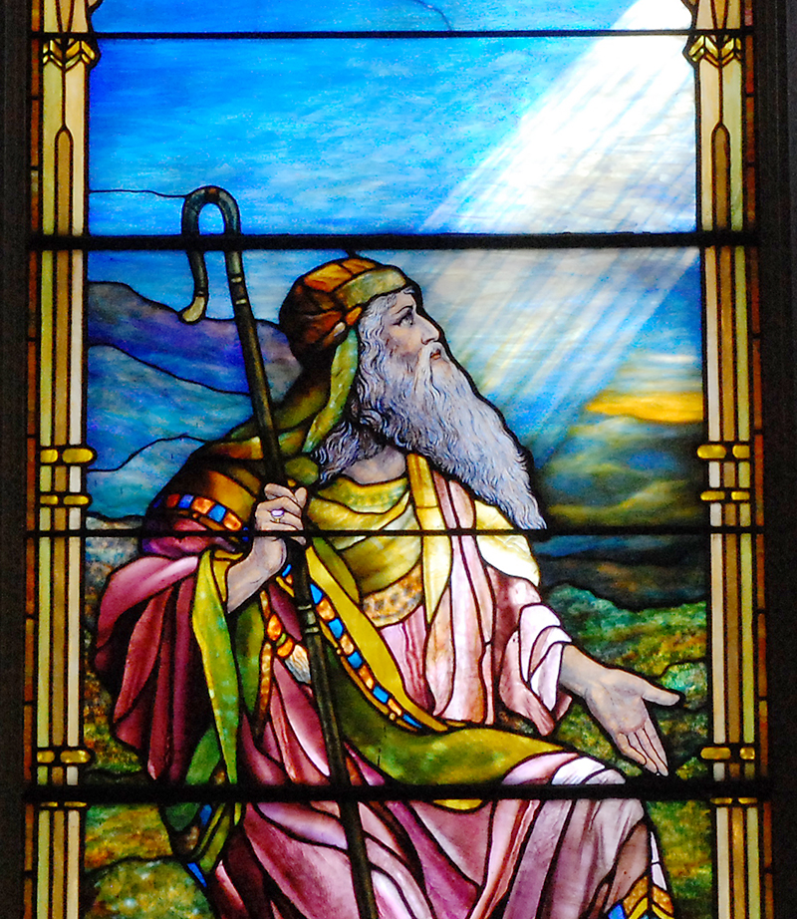Genesis 15: 1-6

After these things the word of the Lord came to Abram in a vision, ‘Do not be afraid, Abram, I am your shield; your reward shall be very great.’ But Abram said, ‘O Lord God, what will you give me, for I continue childless, and the heir of my house is Eliezer of Damascus?’ And Abram said, ‘You have given me no offspring, and so a slave born in my house is to be my heir.’ But the word of the Lord came to him, ‘This man shall not be your heir; no one but your very own issue shall be your heir.’ He brought him outside and said, ‘Look towards heaven and count the stars, if you are able to count them.’ Then he said to him, ‘So shall your descendants be.’ And he believed the Lord; and the Lord reckoned it to him as righteousness.

**Epistle**: Hebrews 11: 1-3, 8-16

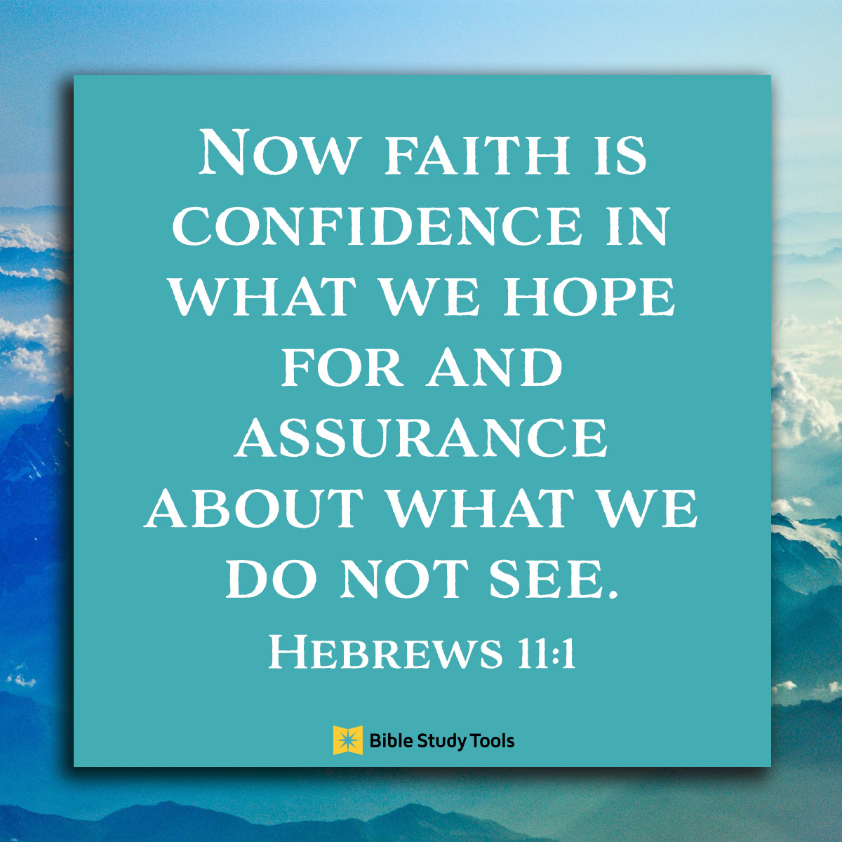Now faith is the assurance of things hoped for, the conviction of things not seen. Indeed, by faith our ancestors received approval. By faith we understand that the worlds were prepared by the word of God, so that what is seen was made from things that are not visible. By faith Abraham obeyed when he was called to set out for a place that he was to receive as an inheritance; and he set out, not knowing where he was going. By faith he stayed for a time in the land he had been promised, as in a foreign land, living in tents, as did Isaac and Jacob, who were heirs with him of the same promise. For he looked forward to the city that has foundations, whose architect and builder is God. By faith he received power of procreation, even though he was too old—and Sarah herself was barren—because he considered him faithful who had promised. Therefore, from one person, and this one as good as dead, descendants were born, “as many as the stars of heaven and as the innumerable grains of sand by the seashore.” All of these died in faith without having received the promises, but from a distance they saw and greeted them. They confessed that they were strangers and foreigners on the earth, for people who speak in this way make it clear that they are seeking a homeland. If they had been thinking of the land that they had left behind, they would have had opportunity to return. But as it is, they desire a better country, that is, a heavenly one. Therefore, God is not ashamed to be called their God; indeed, he has prepared a city for them.

**Gradual & Acclamation:** Shew us thy mercy, O Lord: and grant us thy salvation. O Lord, thou art become gracious unto thy land: thou hast turned away the captivity of Jacob.

(Cantor) Alleluia, alleluia, alleluia.

**(All) Alleluia, alleluia, alleluia.**

**Lord, thou hast /been our/refuge:**

**from one generation/to a/-nother.**

**Alleluia, alleluia, alleluia**

**Gospel:** Luke 12: 32-40

 ‘Do not be afraid, little flock, for it is your Father’s good pleasure to give you the kingdom. Sell your possessions and give alms. Make purses for yourselves that do not wear out, an unfailing treasure in heaven, where no thief comes near, and no moth destroys. For where your treasure is, there your heart will be also.

‘Be dressed for action and have your lamps lit; be like those who are waiting for their master to return from the wedding banquet, so that they may open the door for him as soon as he comes and knocks. Blessed are those slaves whom the master finds alert when he comes; truly I tell you, he will fasten his belt and have them sit down to eat, and he will come and serve them. If he comes during the middle of the night, or near dawn, and finds them so, blessed are those slaves.

‘But know this: if the owner of the house had known at what hour the thief was coming, he would not have let his house be broken into. You also must be ready, for the Son of Man is coming at an unexpected hour.’

**Sermon**: preacher: Fr Russell Duncan

**Intercessions** *(p.14)*:

**Sick, housebound and those in need**: Andy Bayliss, Martin Boland, Philip Bradfield, Peter Dickins, Christine Dunbar, Betty Duncan, Mary Findlay, David Glews, Morag Graham Brown, Sarah Gundry, Di McAdam, Euan Morley, Suzanna Ovenstone, Angelica Paterson, Christine Percival, Isobel Poole, Michele Russell, Jean Simpson and Susan Virtue.

**Year’s mind:** Alfred Hope Patten, Charles Collier, Donald Rutherford, Henry Walter Stein, Edward Holmes, Ronald Lugton, David Lugton, George McMonies, John Stephenson, Jean Hull, Rosemary Crichton, John White, James Hines, Douglas Goodfellow.

***Please stand for The* Peace**(*p.15*)

***The Peace*** *may be exchanged in the traditional way, but please be sensitive towards those who do not wish to do so.*

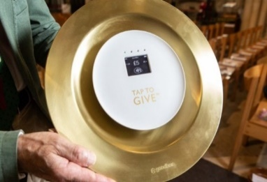**The Offertory:** *If you wish to make a cash donation, please place it in an envelope (to be found in the front of the hymn book) and it will be collected during the hymn. Contactless donations may be made by using our giving plate at the back of the church. Standing order is the preferred method of regular giving.*

*Please consider Gift Aid for your donations.*

**Offertory**: My hope hath been in thee, O Lord: I have said, Thou art my God, my time is in thy hand

**Offertory hymns: 18 Ye servants of the Lord**

**408 Love divine all loves**

**The Prayer of Consecration** *(p.18)*

*The Sanctus and Benedictus this morning are extended and reflective pieces, and so the remainder of the Christological Prayer (p.19) will be said quietly by the Priest whilst this is being sung. This is authentic to the period in which Haydn composed this Mass. The doxology at the end of the prayer (page 22) is said by the priest to unite these parts.*

**The Invitation and Communion***(p.26)*

**Communion Sentence:** The bread that I will give is my Flesh: which I will give thee for the life of the world.

**The Distribution**

**Everyone** is welcome to come forward at the giving of Communion, either to receive the Sacrament or a personal blessing.

**Communion anthem:** *Ave verum* *corpus* – W. A. Mozart(1756 – 1791)

**Ave verum corpus, natum  
de Maria Virgine,  
vere passum, immolatum  
in cruce pro homine  
cuius latus perforatum  
fluxit aqua et sanguine:  
esto nobis praegustatum  
in mortis examine.**

**Hail, true Body, born  
of the Virgin Mary,  
having truly suffered, sacrificed  
on the cross for mankind,  
from whose pierced side  
water and blood flowed:  
Be for us a sweet foretaste  
in the trial of death!**

**Communion hymn: 232 Awake my soul**

**Post-communion collect** (*p.28*)**:**  Eternal God, grant unto thy Church that unity and peace, the fruits of thy life-giving Spirit, which we have tasted in this Eucharist: this we ask in the name of thy Son, Jesus Christ, our Lord. **Amen.**

**Angelus** (*p.29*)

**Recessional hymn:** **361 Forth in the peace**

**Organ Music:** *Fugue from Organ Sonata No. 2 (Op. 65) -* Felix Mendelssohn (1809-1847).

***Please join us after the service for refreshments at the back of the church***

**Notices for week beginning August 11th 2024**

**Tuesday, August 13 · 1 - 2pm**

**Dance at Old Saint Paul's Church: Dancing Ash Wednesday**

TS Eliot’s poem Ash Wednesday is widely regarded as a work of great spiritual depth. Its images are full of movement, making it highly suggestive for choreography and the art of dance. Paul Burrows (dancer/priest) has created a piece in which movement interacts with the speaker in Eliot’s poem; narrated by George Ormerod. A highly unusual integration of the arts of dance and poetry.

**Opening the Church during the Festival**

Edinburgh’s Arts Festival is now on and it would be wonderful if we can gather enough stewards to open the church to visitors during the day. Would you help out?

A list of dates and times is on the Notice Board in the Narthex. Please sign up, if only for one session!

Please ask Faith if you have any questions.

The recipients of the first Michael Jessing bursary are exhibiting their work in the church on August 16th.

Watch out for some of Michael’s work being shown in the Lady Chapel soon.

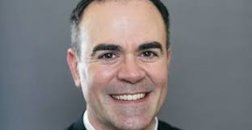Fr Oliver’s institution will be:

**Wednesday 4 September 2024 at 7.00pm here in St Michael and All Saints Church**

**St Salvador’s Community Food Initiative**

Last month Carolyn took over 70 items to St Salvador’s. This was double the amount taken the month before. Well Done everyone. Can we keep this up? St Salvador’s helps 100 families each week.

Please keep everyone informed of what’s going on in church and among our members. Please send items for inclusion on the **next Sunday’s pew sheets** (names of the sick, notices etc) to Helen Daniell by Thursday evening. 0131 660 6056; helen@helendaniell.co.uk

Please check **the availability of the church** before planning

activities. Sam Campbell, the parish administrator, should be **notified of all activities taking place in the church and all bookings** should be made through her:

[admin@stmichaelandallsaints.org](mailto:admin@stmichaelandallsaints.org)

Interim Pastor: Fr Paul Burrows

E-mail*:***rector@stmichaelandallsaints.org**

|  |  |  |
| --- | --- | --- |
| **Sunday August 11th**  **Ordinary Time 19** | 9.00am  10.30am | Choir Practice  Sung Mass |
| **Monday 12th**  Blane, Missionary, c 590 |  |  |
| **Tuesday 13th**  Jeremy Taylor, Bishop, 1667 |  |  |
| **Wednesday 14th**  Maximilien Kolbe, Priest and Martyr, 1941 | 11.00am | Low Mass *followed by a light lunch* |
| **Thursday 15th**  Mary the Virgin |  |  |
| **Friday 16th** |  |  |
| **Saturday 17th** |  |  |
| **Sunday August 18th**  **Feast of the Assumption of our Lady**  **(transferred )** | 9.00am  10.30am | Choir Practice  High Mass |

