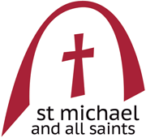**Sunday September 15th 2024**

**The Exaltation of the holy Cross**

***Welcome to this church******and to this service***

This pew-sheet gives details of the parts of the service that change week by week; it should be used with the Mass in Ordinary Time book

(page numbers shown in brackets).

***Everyone*** *is welcome to come forward at the giving of Communion, either to receive the Sacrament or a personal blessing.*

Gluten-free wafers and non-alcoholic wine are available on request. Please let the sidesperson know***.***

**Organ Music:***tbc*

**Mass setting**: Communion Service in F by Harold Darke (1888-1976)

**Welcome and notices**

**Introit Hymn:**  **379 In the cross of Christ I glory**

**Introit** *(p3*): But as for us, it behoveth us to glory in the Cross of our Lord Jesus Christ: in whom is our salvation our life, and resurrection; by whom we were saved and obtained our free - dom. Ps. God be merciful unto us and bless us: and shew us the light of his countenance, and be me

**The Kyries** *(p3):*

**Gloria***(p5): setting by Jeffcoat:*

**Collect** *(p8****):*** O God, who on this day dost gladden us with the yearly solemnity of the Exaltation of the holy Cross: grant, we beseech thee; that we, who on earth have known the mystery of the redemption which thy Son hath wrought for us, may likewise attain unto the reward thereof in heaven. Through the same Jesus Christ our Lord, who liveth and reigneth with thee, in the unity of the Holy Spirit, ever one God, world without end.

**AMEN.**

**First Reading:**  Numbers 21: 4 - 9

From Mount Hor they set out by the way to the Red Sea,[*](javascript:void(0);) to go around the land of Edom; but the people became impatient on the way. The people spoke against God and against Moses, ‘Why have you brought us up out of Egypt to die in the wilderness? For there is no food and no water, and we detest this miserable food.’ Then the Lord sent poisonous serpents among the people, and they bit the people, so that many Israelites died. The people came to Moses and said, ‘We have sinned by speaking against the Lord and against you; A stained glass window with a religious scene
pray to the Lord to take away the serpents from us.’ So Moses prayed for the people. And the Lord said to Moses, ‘Make a poisonous serpent, and set it on a pole; and everyone who is bitten shall look at it and live.’ So Moses made a serpent of bronze, and put it upon a pole; and whenever a serpent bit someone, that person would look at the serpent of bronze and live.

**Epistle**: 1 Corinthians 1: 18 -24

For the message about the cross is foolishness to those who are perishing, but to us who are being saved it is the power of God. For it is written,  
‘I will destroy the wisdom of the wise,  
   and the discernment of the discerning I will thwart.’  
Where is the one who is wise? Where is the scribe? Where is the debater of this age? Has not God made foolish the wisdom of the world? For since, in the wisdom of God, the world did not know God through wisdom, God decided, through the foolishness of our proclamation, to save those who believe. For Jews demand signs and Greeks desire wisdom, but we proclaim Christ crucified, a stumbling-block to Jews and foolishness to Gentiles, but to those who are the called, both Jews and Greeks, Christ the power of God and the wisdom of God.

**Gradual & Acclamation:**  Christ became obedient for our sakes unto death: even the death of the Cross. Wherefore God also hath highly exalted him: and given him a Name which is above every name.

(Cantor) Alleluia, alleluia, alleluia.

**(All) Alleluia, alleluia, alleluia.**

**Sweetest wood, sweetest iron, that bare so sweet a Bur - den: which only was counted worthy to sustain the King of heaven and its Lord.**

**Gospel:** John 3: 13 - 17

No one has ascended into heaven except the one who descended from heaven, the Son of Man. And just as Moses lifted up the serpent in the wilderness, so must the Son of Man be lifted up, that whoever believes in him may have eternal life.

‘For God so loved the world that he gave his only Son, so that everyone who believes in him may not perish but may have eternal life.

‘Indeed, God did not send the Son into the world to condemn the world, but in order that the world might be saved through him.

**Sermon**: Fr Oliver Brewer Lennon

**Intercessions** (p14):

**Sick, housebound and those in need**: Andy Bayliss, Martin Boland, Philip Bradfield, Peter Dickins, Christine Dunbar, Betty Duncan, Mary Findlay, David Glews, Morag Graham Brown, Sarah Gundry, Di McAdam, Euan Morley, Suzanna Ovenstone, Angelica Paterson, Isobel Poole, Jean Simpson and Susan Virtue.

**Year’s mind:**  Victoria Maud Bevin, Annie Moses, Uvedale Lambert, Fr Geoffrey Law, Frederick Charles Gould, Ruth Andean, Owen Knowles, James Brumfitt, Sarah Wylie and Kenneth Hay,

***Please stand for* The Peace**(*p.15*)

***The Peace*** *may be exchanged in the traditional way, but please be sensitive towards those who do not wish to do so.*

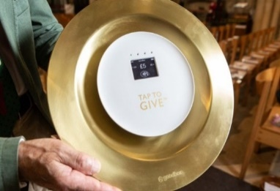**The Offertory:** *If you wish to make a cash donation, please place it in an envelope (to be found in the front of the hymn book) and it will be collected during the hymn. Contactless donations may be made by using our giving plate at the back of the church. Standing order is the preferred method of regular giving.*

*Please consider Gift Aid for your donations.*

**Offertory Sentence**: By the sign of the Cross, defend, O Lord, thy people from all the snares of our enemies; that the service which we render may be pleasing unto thee, and our sacrifice acceptable in thy sight, alleluia.

***Fr Oliver has begun to say The***[***Secret***](https://www.catholic.com/encyclopedia/secret)***(Lat. Secreta, sc. oratio secreta). The prayer is said in a low voice by the celebrant at the end of the***[***Offertory***](https://www.catholic.com/encyclopedia/offertory)***. It is the original and, for a long time, was the only offertory prayer. It is said in a low voice merely because at the same time the choir sings the***[***Offertory***](https://www.catholic.com/encyclopedia/offertory)***, and it has inherited the special name of***[***Secret***](https://www.catholic.com/encyclopedia/secret)***as being the only prayer said in that way.***

**The Secret:** O Lord our God, who dost fulfil us with the Body and Blood of Jesus Christ our Lord, through whom thou hast sanctified the standard of the Cross: we beseech thee; that as we have been counted worthy to venerate that Cross, so we may effectually be made partakers of its glory unto everlasting salvation. Through the same thy Son Jesus Christ our Lord who liveth and reigneth with thee in the unity of the Holy Ghost, ever one God, world without end.

**Offertory hymns: 95 *When I survey the wondrous cross***

**310 *We hail thy presence glorious***

**The Prayer of Consecration** *(p.18)* ***including the Preface***

**Proper Preface:**  Who by the tree of the Cross didst give salvation unto mankind: that whence death arose, thence life might rise again: and that he who by a tree overcame might also by a tree be overcome. Therefore with Angels…

**The Invitation and Communion** *(p.26)*

**Communion Sentence:** By the sign of the Cross deliver us from our enemies; O Lord our God.

**The Distribution**

**Everyone** is welcome to come forward at the giving of Communion, either to receive the Sacrament or a personal blessing.

**Communion anthem:** *Crux Fidelis* attrib. King John of Portugal (1604-1656)

Crux fidelis, inter omnes arbor una nobilis;

nulla talem silva profert, flore, fronde, germine,

dulce lignum, dulci clavo, dulce pondus sustinens!

O faithful cross! The one noble tree, among all trees;

no forest yields your like, in foliage, flower and fruit;

sweet is the wood bearing, a sweet burden with a sweet nail

**Communion hymn:** **274 Author of life divine**

**Post-communion collect** (*p.28*)**:** Assist us mercifully, O Lord our God: that we whom thou dost suffer to rejoice in honouring the holy Cross; may be defended by the perpetual succour of the same. Through Jesus Christ our Lord, who liveth and reigneth with thee, in the unity of the Holy Spirit, ever one God, world without end.

**Amen.**

**The Blessing:** Christ crucified draw you to himself, to find in him a sure ground for faith, a firm support for hope, and the assurance of sins forgiven; and the blessing of God almighty, the Father, the Son, and the Holy Spirit, be among you and remain with you always. **AMEN.**

**Angelus** (*p.30*)

**Recessional hymn:** **439 Praise to the Holiest in the Height**

**Organ Music:** *tbc*

***Please join us after the service for refreshments at the back of the church***

**Notices for week beginning 15th September**

Church Keys

It has been decided that the yale lock of the church door is to be changed. The new key will be issued to those whose name is on the key register, which is held currently by Sheena Liddell. If you are a key holder, you need to check your name is on her list.

**Sunday September 22nd**

**Harvest Festival.**

High Mass – 10.30

Please bring in non-perishable harvest gifts for the Food Bank.

At this mass there will be a talk by someone from Maggie’s, our local charity for this year.

**Maggie's** centres are a network of drop-in centres across the United Kingdom and abroad that aim to help anyone who has been affected by cancer.

They are intended as welcoming and caring environments that provide support, information and practical advice to people dealing with a cancer diagnosis. They also offer wellbeing sessions and workshops to complement conventional cancer therapy

D**oors Open Day** is the weekend of **28th and 29th September**. We will be open on Saturday 28th Sept from 11:00am to 4:00pm **AND** on Sunday from noon to 4:00pm.

We will need volunteers to welcome visitors and steward this event which has been very popular in the last few years with more than 150 people coming through our open doors. People are being asked to do 2-hour slots. The rota is on the noticeboard. Please sign up and help us have the church open.

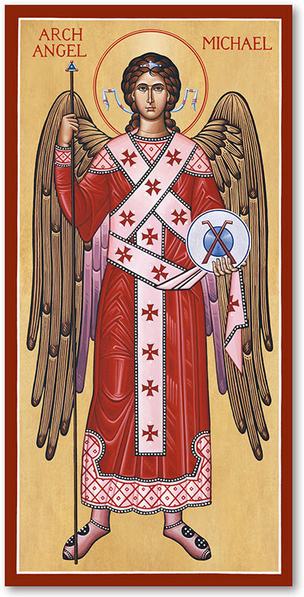

**Sunday September 29th**

**Feast of St Michael and All Angels**

There will be a High Mass for our first patronal festival at 10.30.

**Our prayers are asked for those who are to be ordained to the diaconate on Sept 29th at St Mary’s Cathedral - Eilidh Proudfoot, Fiona Reynolds and Simon Scholfield.**

**Fr Paul Burrows**

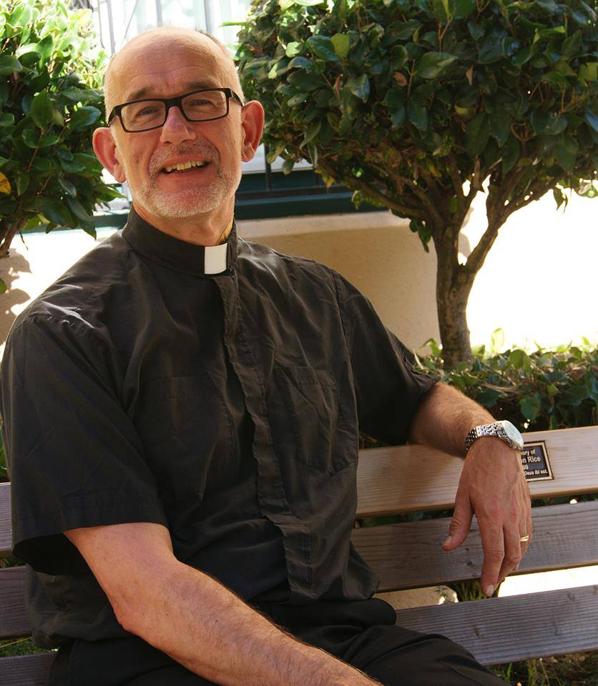Fr Paul Burrows celebrated his final Mass as our Interim Pastor on Sunday 1 September 2024.

As a congregation we have valued his pastoral care and his regular presence at the altar over the last 16 months. As a Vestry we have appreciated his wise input at our meetings.

We have been so fortunate.

We thank Fr Paul most sincerely for all he has done and all he has been to us during the Interregnum. With sadness we say farewell to someone who was not just an Interim Pastor but someone who became such an integral and active part of our church life.

We wish him well wherever he might be called next.

**Sheena Liddell – Vestry Chair**

Please keep everyone informed of what’s going on in church and among our members. Please send items for inclusion on the **next Sunday’s pew sheets** (names of the sick, notices etc) to Helen Daniell by Thursday evening. 0131 660 6056; [helen@helendaniell.co.uk](mailto:helen@helendaniell.co.uk)

Please check **the availability of the church** before planning

activities. Sam Campbell, the parish administrator, should be **notified of all activities taking place in the church and all bookings** should be made through her:

[admin@stmichaelandallsaints.org](mailto:admin@stmichaelandallsaints.org)

Rector: Fr Oliver Brewer Lennon

Email*:* [**rector@stmichaelandallsaints.org**](mailto:rector@stmichaelandallsaints.org)

Phone: [07954 314 374](tel:+44+(0)+7954+314+374)

Scottish Charity no. SC016184

|  |  |  |
| --- | --- | --- |
| **Sunday September 15th**  **The Exaltation of the Holy Cross**  **(transferred)** | 9.30am  10.30am | Choir Practice  **High Mass (r)** |
| **Monday 16th**  **Ninian of Whithorn, Bishop, sixth century** |  |  |
| **Tuesday 17th**  Hildegard of Bingen, Abbess, 1179 |  |  |
| **Wednesday 18th** | 11.00am | **Low Mass** *followed by a light lunch* |
| **Thursday 19th** |  |  |
| **Friday 20th**  John Coleridge Patteson, Bishop and Martyr, 1871 |  |  |
| **Saturday 21st**  **Matthew, Apostle and Evangelist** |  |  |
| **Sunday September 22nd**  **Harvest Thanksgiving** | 9.00am  10.30am | Choir Practice  **High Mass (r)** |